Virtual Outlet

Path : billing.petpooja.com >> Menu >> Menu & Discount >> Add Virtual Outlet.
Outletwise_link: https://menu.petpooja.com/menus/virtual_brand/
Steps to reach Add Virtual Outlet:
Step 1: billing.petpooja.com in Steps to Reach Add Virtual Outlet: Open your browser, go to billing.petpooja.com, and log in with your credentials.
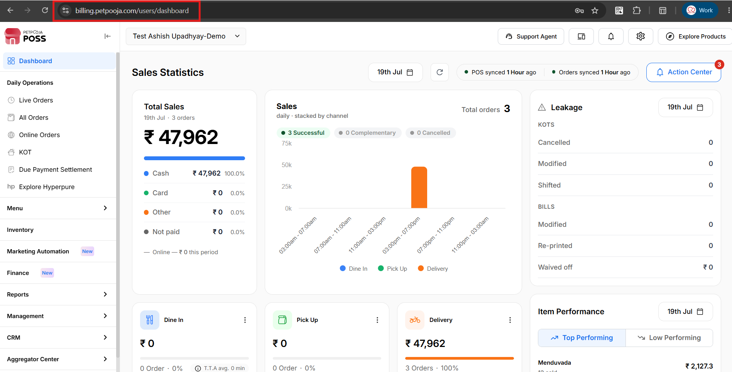
{Image Name: PetPooja Dashboard,
Description: The highlighted URL indicates that this is the billing.petpooja.com. Here is an image of Step 1 billing.petpooja.com in Steps to reach Add Virtual Outlet.}
Step 2: Menu in Steps to Reach Add Virtual Outlet: Once logged in, click on the "Menu" menu from the left-side navigation panel on the dashboard.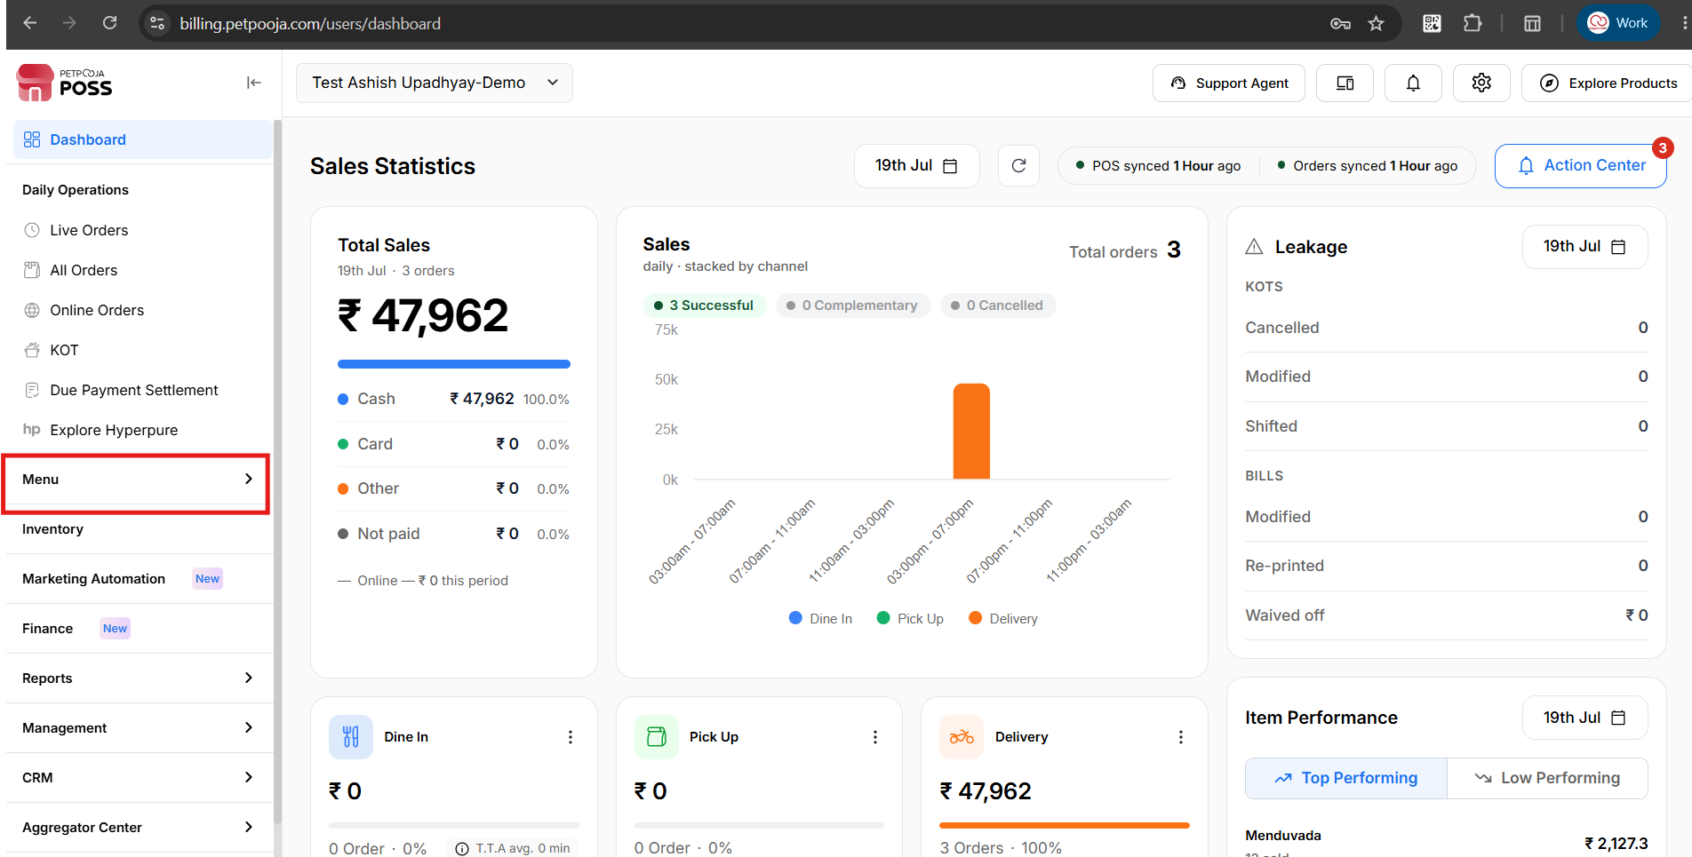
{Image Name: PetPooja Menu,
Description: The highlighted section indicates the "Menu" option on the left-side panel of the PetPooja dashboard. This allows users to manage menu items and categories. Here is an image of Step 2 Menu in Steps to reach Add Virtual Outlet.}
Step 3: Menu & Discount in Steps to Reach Add Virtual Outlet: Inside "Menu," select "Menu & Discount" to access and adjust settings specific to your restaurant's operations.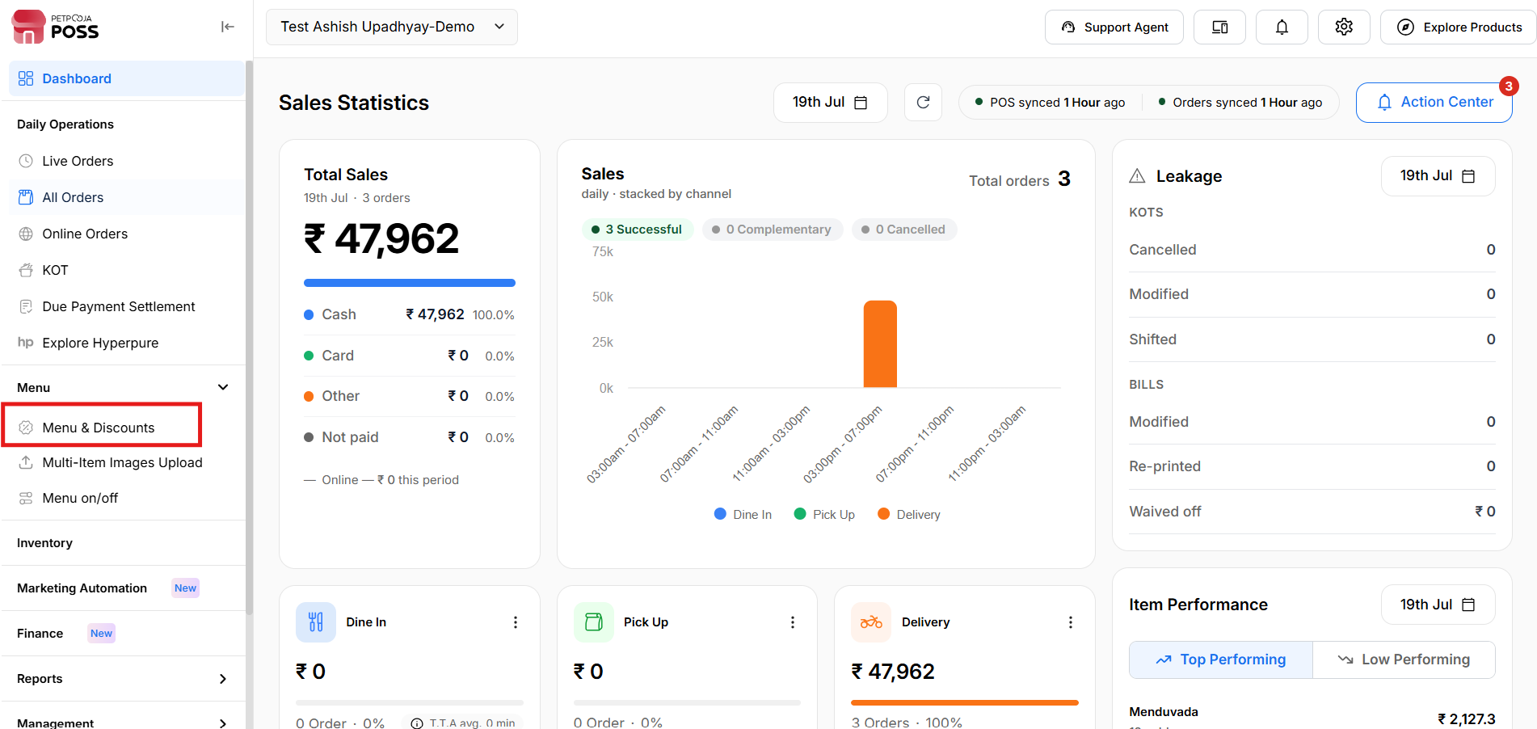
{Image Name: PetPooja Menu & Discount,
Description: The image shows the "Menu & Discount" section within the "Menu" page. This section lets users manage menu items and discounts. Here is an image of Step 3 Menu & Discount in Steps to Reach Add Virtual Outlet.}
Step 4: Add Virtual Outlet in Steps to Reach Add Virtual Outlet: Click on the “Add Virtual Outlet” after selecting "Menu & Discount."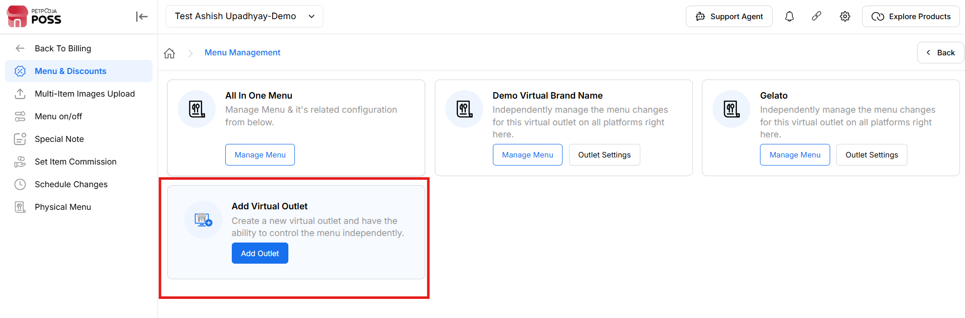
{Image Name: Add Virtual Outlet,
Description:This screen allows you to create a new virtual outlet. It enables independent menu control for each outlet by using the "Add Outlet" option under the "Add Virtual Outlet" section.}

Add Virtual Outlet (Virtual Outlet) :
Outletwise_link: https://menu.petpooja.com/menus/virtual_brand/

Create Virtual Outlet (Add Virtual Outlet) :
Outletwise_link: https://menu.petpooja.com/menus/virtual_brand/
- (Create Virtual Outlet) Virtual Brand Name*: Required field to enter the name of the virtual brand.
- (Create Virtual Outlet) Applicable Taxes: Dropdown list to select relevant tax rates (e.g., 2.5% SGST, CGST, IGST).
- (Create Virtual Outlet) Virtual Brand Logo: Upload option to add the brand’s logo (image file).
- (Create Virtual Outlet) Bill Print Header / Footer: Text fields for custom messages or branding that will appear on the top and bottom of printed bills.
- (Create Virtual Outlet) Status: Checkbox to mark the brand as active/inactive.

(Create Virtual Outlet) Select Categories For Brand*:Required checkboxes to tag the brand with relevant food categories, such as :
  - Non-Veg Starters
  - Veg Starters
  - Paneer Sabji

(Create Virtual Outlet) Select Add-ons Selection : Checkboxes to define optional add-ons associated with the brand, including
  - Beverage
  - Toppings
  - Noodles
  - Extra
  - Jain (no-onion/garlic option for specific dietary needs)
(Includes "Select All" option)
- (Create Virtual Outlet) Cancel: Discards any changes made in the form. Usually closes the form or redirects back to the previous screen without saving.
- (Create Virtual Outlet) Save Changes: Saves the information entered or modified in the form.Validates the form and submits the data to the backend for processing or database update.
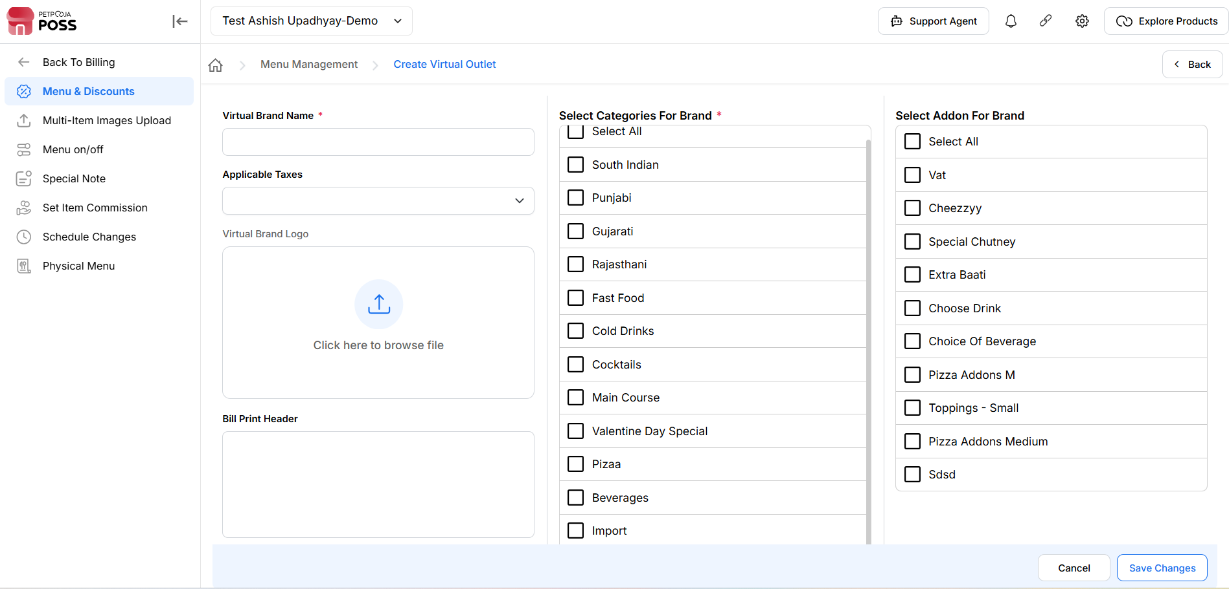
{Image Name: PetPooja Create Virtual Outlet,
Description: Here is an image showing the "Create Virtual Outlet" interface in PetPooja}

Outlet Settings (Virtual Outlet) :
https://menu.petpooja.com/menus/virtual_brand/7288
Purpose (Outlet Settings) : The button is probably used to access or modify configuration options related to an outlet which could refer to a power outlet, retail location, or some service endpoint, depending on the context of the application.
- Expected Action on Click: When a user clicks this button, it would likely open a new page, modal, or dropdown with various settings and controls specific to the outlet.
- (Outlet Settings) Changing the outlet name.
- (Outlet Settings) Uploading or modifying the virtual brand logo.
- (Outlet Settings) Editing the bill print header and footer.
- (Outlet Settings) Setting the bill print status as Active or Inactive.
- (Outlet Settings) Selecting categories for the brand.
- (Outlet Settings) Assigning add-ons to the brand.
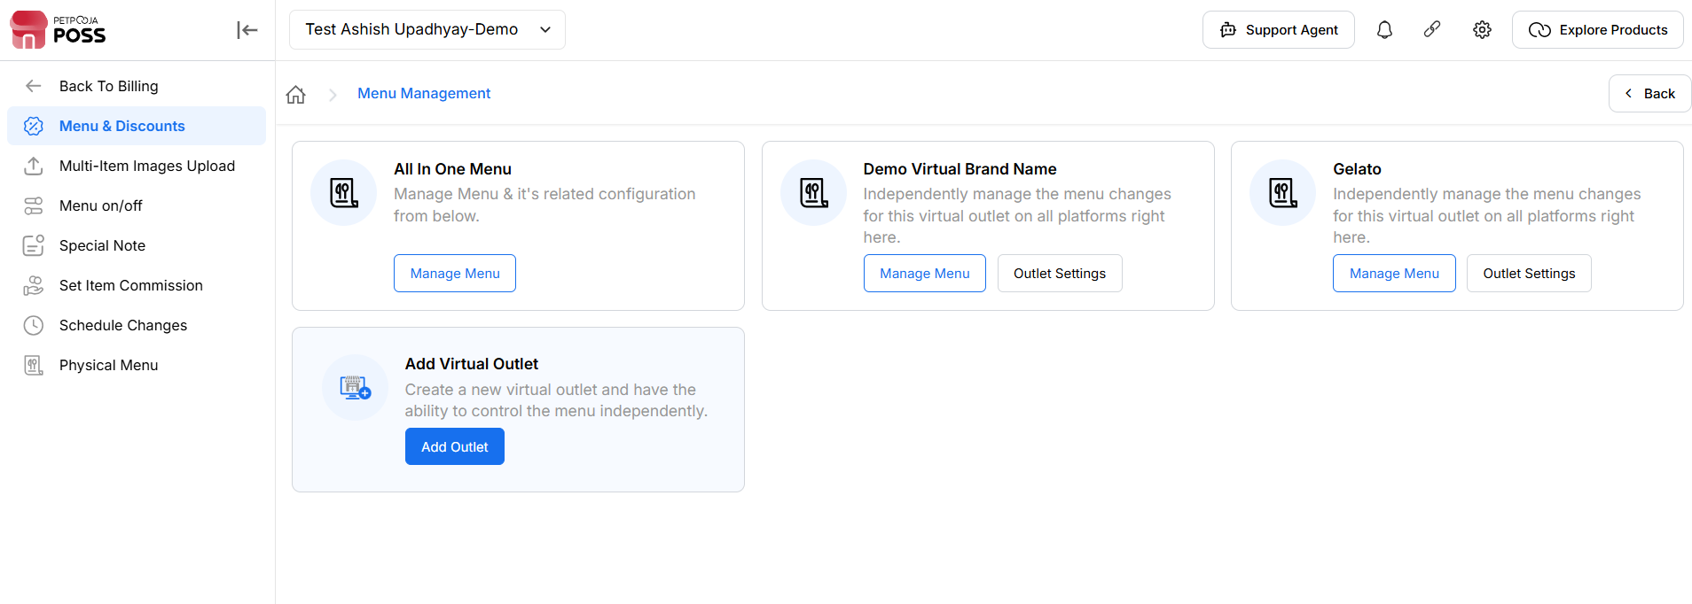
{Image Name: Out Settings,
Description: Here is an image showing the "Outlet Settings" option highlighted under the Testing section, which allows independent menu management for a virtual outlet.}

Note (Virtual Outlet):if there are any changes to Virtual Outlet from the dashboard for online,you have to do the menu trigger because it is mandatory.

